**DEFINE PROJECT**

**Project name Food Tracking System**

**NM ID** 89E2CECF512316C8FD14B71F23E03E8B

**Document DEFINE PROJECT**

**Food Track and Trace Solutions**

Safe food consumption is one of the main things to be considered for a healthy life. The World Health Organization [(WHO)](https://www.who.int/activities/estimating-the-burden-of-foodborne-diseases) stated that 600 million people get sick and 420 thousand people die every year due to unsafe food products. The increase in accessible data and cases has also increased consumers’ awareness of safe food. Aware of the situation, states are working to ensure access to safe food with legal regulations and to ensure that food can be traced throughout the supply chain. While the increase in food destruction negatively affects health, it also causes serious economic losses. In order to prevent losses, companies have concentrated their studies on food safety in the light of technological developments.

The use of traceability technologies is the most effective way for consumers to access safe food. Food traceability covers defining the processes and products in the supply chain, recording them and sharing the recorded information if requested.

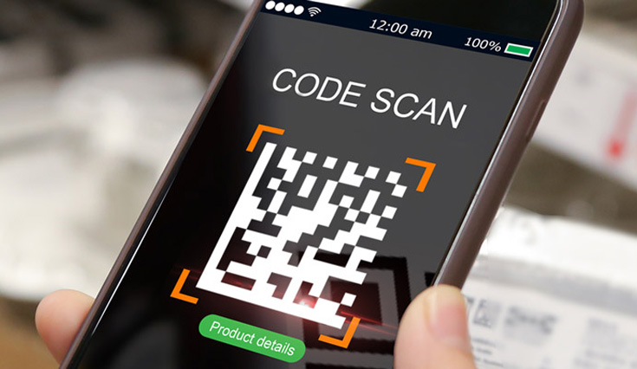

The globalization of the economy and the increasing acceleration of imports and exports in trade have made it mandatory to follow the products in a controlled manner at every stage. Traceability, which provides a significant benefit by keeping human health as far away from risks as possible, has many benefits in production optimization. Thanks to the system that can provide backward and forward monitoring, both the source of the problem can be found and crisis management can be performed in a healthy way. As the information recorded in the system cannot be changed in food traceability, it prevents counterfeiting and tarnishes brand’s quality. Effective use of raw materials, planning in production, determination of non-standard products, and practicalization of logistics activities are some of the gains.

Traceability is regulated by laws in Australia, Canada, Turkey and many other countries, especially the USA and the EU. Businesses that do not want to compromise their quality and brand image also use food traceability technologies effectively. Traceability systems can be applied as “full traceability”, “one step back and one step forward”. Food traceability technologies develop with the questions of “what, where, when, for what purpose”, taking into account the international market requirements. An ID must be assigned to each product at the beginning of the production in order to answer these questions. The most practical method that can be applied for the serialization process is [GS1](https://www.gs1.org/) compliant data matrix code. The fact that the information that can be transferred is detailed and the operation is low cost has made the use of data matrix widespread.

In addition to the serialization and aggregation systems used for traceability, the use of weight measuring technologies for food is also very important. The weight information on the product packaging and the inconsistency of the product weight will negatively affect the reputation of the company. Inconsistent weight causes legal sanctions, which is another negativity for businesses. High-tech automatic checkweighers measure the weight of products within the specified value ranges without interrupting the production speed. In this way, the reputation of the company is guaranteed and legal compliance is realized.